CODING PROJECT
Day 3 – Discovering the Vision

Project: Michael's Foundations
Development Day: Day 3
Date: August 3, 2026
Time Invested: 2 Hours 15 Minutes
Primary Focus: Portfolio Architecture & Vision
Version: Portfolio v0.3

Objectives
Today's objectives were to continue improving the Portfolio Website while making it more organized, scalable, and professional. During development, a much larger objective emerged: defining the long-term vision for Michael's Foundations and establishing the architectural direction of the entire software ecosystem.

Today’ Accomplishment ★★★★★
"Today the project transformed from a portfolio into an educational software ecosystem."

Today's Progress-
Portfolio Improvements
- Added the Spanish Foundations project card.
- Positioned Russian Foundations and Spanish Foundations side-by-side.
- Created reusable Language Code labels (RU and ES).
- Introduced reusable Project Category headings.
- Divided the Featured Projects into separate project grids to prepare for future expansion.
- Continued organizing and refactoring the CSS into logical sections.
- Improved the overall architecture of the Portfolio Website.

A Turning Point
Today became much more than a coding session.
During our discussion I realized that I am not simply building a portfolio website.
I am building an educational software ecosystem.
Every Foundation Project represents a different area of my life and experience, connected together through a common philosophy of teaching, learning, and software development.
This realization fundamentally changed how I think about the project.
Rather than asking,
"How do I build another webpage?"
I now ask,
"How do I build an educational software ecosystem that can continue growing for years?"

Vision Discovered
One of today's biggest realizations was understanding that my goal is not simply to become a software developer. My goal is to become a software architect who designs educational software that helps people learn, think, and grow.

Michael's Foundations is becoming a platform that combines my experiences as:
- Computer Science Educator
- Russian Linguist
- Spanish Linguist
- Missionary in South America
- Musician
- Competitive Arm Wrestler
- Software Developer

Every future project should naturally fit within this ecosystem.

Michael's Foundations Ecosystem
Current Foundation Series
🌍 Language Foundations
- Russian Foundations
- Spanish Foundations
🎼 Music Foundations
- Piano Foundations
- Organ Foundations
- Pan Flute Foundations
- Harmonica Foundations
- Music Theory (Future)
♟ Specialized Foundations
- Chess Foundations
- Arm Wrestling Foundations
- Teacher Toolkit
Teacher Toolkit will eventually include:
- Classroom Resources
- Curriculum Maps
- Productivity Architect
- AI Foundations
- Prompt Engineering
- AI Ethics
- Workflow Systems

Educational Philosophy
These principles will permanently guide every AI-related project within Michael's Foundations.

Core Philosophy
"AI is not a replacement for thinking. AI is a workflow amplifier for human intelligence."

Mission
"Train teachers to use AI effectively and ethically while guiding students to use AI responsibly, creatively, and strategically."

Guiding Principle
"AI can assist the thinking process, but never replace the thinking responsibility."
These statements define how AI should be integrated throughout Teacher Toolkit and every future AI educational resource.

Architectural Decisions
Today's discussion resulted in several important architectural decisions.

Michael's Foundations is no longer viewed as a collection of projects.
It is now viewed as an educational software ecosystem.

Every Foundation Project belongs to a larger family.
Projects should be grouped into logical categories rather than existing as unrelated applications.

Teacher Toolkit becomes the home of The Productivity Architect.
The Productivity Architect was not a failed project. It was an early expression of the educational philosophy that now belongs within Teacher Toolkit.

Every Foundation Project should follow a common architecture.
Projects should feel related through:
- Navigation
- Layout
- Components
- Branding
- Educational philosophy
- User experience

Software Development Order
Future projects should always follow this sequence:
- Vision
- Architecture
- Reusable Components
- Code
The code exists to support the vision—not the other way around.

Developer Wisdom
Today's coding session reinforced several important lessons.
- Build systems instead of isolated pages.
- Design for future growth.
- Organize before expanding.
- Reusable components reduce future work.
- Great software begins with architecture.

Personal Reflection
Today I realized that Michael's Foundations is becoming far more than a coding portfolio.
It is becoming the digital expression of my life's work. My experiences in education, language, music, software development, athletics, and AI are no longer separate interests.

They are becoming one unified educational platform. For the first time, I can clearly see the long-term direction of this project. This realization has given the project a much deeper purpose and a much clearer identity.

Quote of the Day
"The code exists to support the vision—not the other way around."

Final thoughts
Think of it as The Development History of Michael's Foundations.
Imagine someone opening it five years from now. They wouldn't just see what code you wrote—they would see how an idea evolved into a professional software ecosystem.

The Blueprint – in the first stages of development

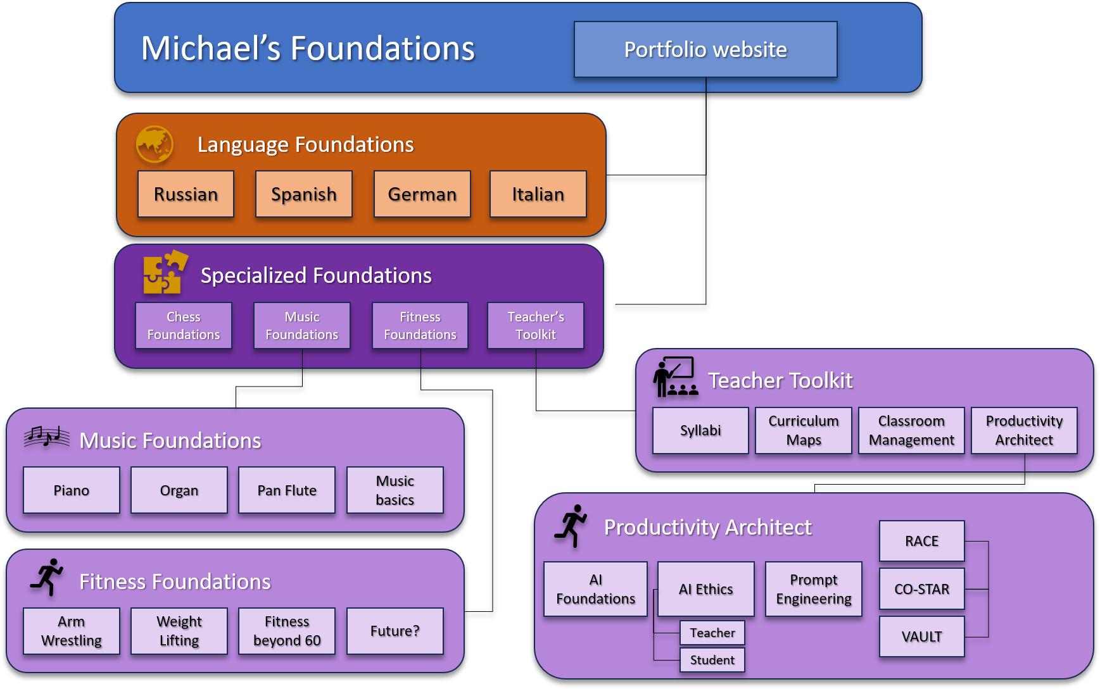

Day three evolution:
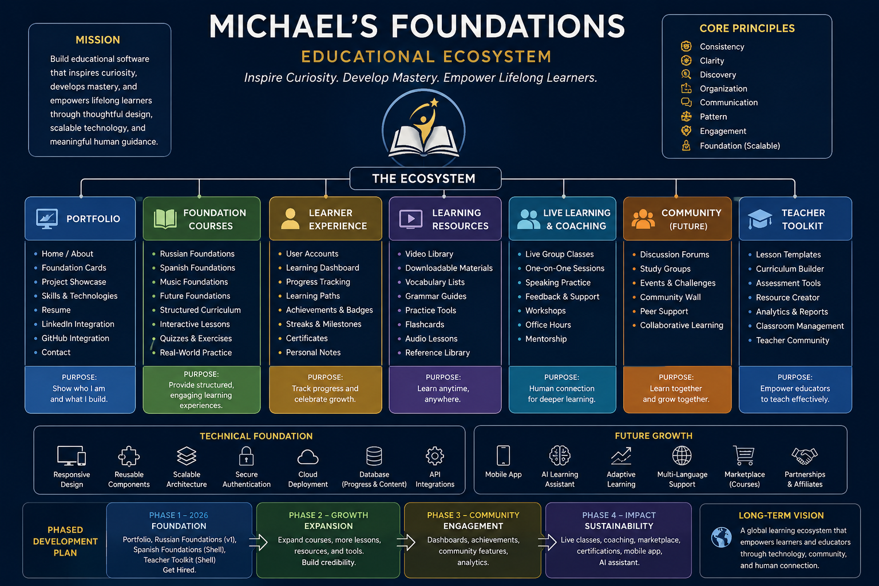

Coding Project – Day 5
Vocabulary Foundations (Version 1)
Major Accomplishments
- Built the first complete Foundation page.
- Created a reusable Journey Card component.
- Used Design Tokens and Component Standards instead of writing isolated CSS.
- Simplified the hero by removing unnecessary explanatory text.
- Promoted the encouragement message ("Your first step is simpler than you think!") to the tagline, improving the user experience.
- Organized six vocabulary journeys into a 3×2 grid for visual consistency with the Portfolio Website.
- Made small UI refinements by narrowing the Learning Principle card and increasing the icon size after reviewing the page from the learner's perspective.
Lessons Learned
- Every sentence should have a purpose.
- Consistency creates confidence.
- Small refinements often improve the experience more than major redesigns.
- Stop polishing when the page fulfills its purpose.

Here's what you now have:
- Career Roadmap → Where you're going.
- Foundation Framework → How the learning experience is organized.
- Design Philosophy → Why you make design decisions.
- Component Standards → How the UI is built.
- Coding Standards → How the code is written.
- Developer Journal / Coding Journal → How you learned and improved.

That collection tells a much richer story than code alone.

